THE STATIONS OF THE RESURRECTION

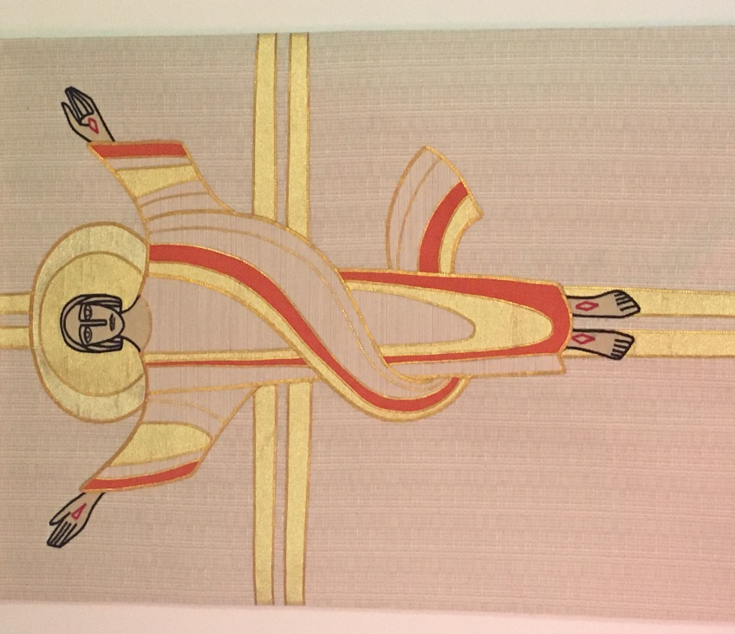

BENEFICE OF TANFIELD WITH BURNOPFIELD AND DIPTON

We begin with words of Gathering
In the name of the Father,
and of the Son,
and of the Holy Spirit.
Amen.

Alleluia. Christ is risen.
He is risen indeed. Alleluia.

Let us pray. Keep silence for a few moments.

God of glory,
by the raising of your Son
you have broken the chains of death and hell:
fill your Church with faith and hope;
for a new day has dawned
and the way to life stands open
in our Saviour Jesus Christ.
Amen.

We come now to the Stations themselves.
These can be prayed through in their entirety or you might prefer to work your way through one or several each day, whatever feels right for you.

- Begin by saying the name of the Station
- Follow this by saying

Jesus is the resurrection and the life.
Those who believe in him shall never die. Alleluia.

- Read the scripture which accompanies the Station. Afterwards, you may like to use the reflection provided and/or keep a short period of silence.
- When you are ready, conclude the Station by saying the following acclamation

Praise to you, Lord Jesus:
Dying you destroyed our death,
rising you restored our life:
Lord Jesus, come in glory.

- Continue by saying the name of the next Station and follow the pattern outlined above.
- Whether you do a few Stations at a time or all of them at once, it is good to finish this spiritual exercise with the Conclusion on p.14

First Station: The earthquake
Matthew 28 v2-4
Reflection
Lest our resurrection musings gravitate towards the ‘cosy’, then here is a dramatic beginning to shake us out of such complacency: an earthquake, an angel, and the rolling back of an immensely heavy stone. No wonder the guards shook! The resurrection of Jesus shatters all previous understanding and reality: just as the geographical landscape, the earth, is altered, so too the human landscape of living and dying is forever changed. As we recall the power of resurrection love amidst the backdrop of a pandemic, ask God to be with you during the adjustments and differences we currently experience as part of our daily lives.

Second Station: Mary Magdalene finds the empty tomb
John 20 v1,2
Reflection
We continue in love as we witness the bereft figure of Mary visiting the tomb. Here, in the darkness, she finds questions but no answers. Who moved Jesus? Who rolled away the stone? Where is his body now? The energy of confusion powers her running to Peter and the other disciple (thought to be John). Some of us will identify with Mary and such restless bewilderment that frequently accompanies grief. Similarly, we may recognise from our own experiences of bereavement how we are often left with more questions than answers. Confused helplessness is quite a vulnerable state in which to find ourselves. Who or what helped you during your experiences of grief? In times of distress may the resurrection hope of Jesus dawn in our broken hearts.

Third Station: The disciples run to the empty tomb
John 20 v3-8
Reflection
The two disciples are running and running. A strange competition. The other disciple reaches the place first yet it is Peter who ventures inside the tomb and the prize is…nothing. It is as Mary said: the tomb is empty. No body, merely linen wrappings and a cloth. The other disciple enters; he sees the discarded grave clothes and believes. What does he believe? What do you believe?
Perhaps it is this: love is stronger than death.

Fourth Station: The angel appears to the women
Matthew 28 v5-8
Reflection
Behold the power of love! The women mentioned here are Mary Magdalene and the ‘other Mary’. They approach the tomb and find an angel sitting atop the rolled away stone while the guards are dead faint. In Matthew’s Gospel the angel furnishes them and us with detail: Jesus is not here, he has been raised, he is going ahead of you. Then the angel gives them a quest: deliver this very news to the disciples! Fear and great joy is quite a combination of emotions; even so, the women set about this task.
When all seems lost or is mired in confusion, there is a reminder here that God is still present sustaining us and working in ways beyond our understanding and imagining. God is with us, going ahead of us, guiding us.

Fifth Station: Jesus meets the women
Matthew 28 v9,10
Reflection
Just as the women are engaging in faithful response to the angelic words, they are surprised by the appearance of Jesus. ‘Greetings.’ For the women it is the most natural thing when confronted with the risen Lord: the response is to kneel down and worship in an act of love and adoration. After meeting the purest love, Jesus, their next response is to get up and deliver the most extraordinary news. ‘Go and tell.’
I wonder how you would respond if Jesus suddenly appeared?

Sixth Station: The road to Emmaus
Luke 24 v28-35
Reflection
Another two disciples: grief stricken, confused, they recount the goings on in Jerusalem to a stranger who draws alongside as they walk towards Emmaus. A stranger who recognises their sadness and who listens. A stranger who comforts them, who burns their hearts as he discusses scripture. A stranger they are drawn to urge to stay with them, who they wish to show hospitality and gratitude. But there is a bigger surprise for the stranger, the guest, turns Host: he takes bread, blesses it, breaks it, gives it to them. In this act the disciples’ eyes open and they see the stranger to be Jesus. The fully present Jesus we meet each time we receive the Sacrament.
‘Be present, be present, Lord Jesus Christ, our risen high priest,
and make yourself known in the breaking of the bread.’

Seventh Station: Jesus appears to the disciples
Luke 24 v36-43
Reflection
The two disciples who met with Jesus respond like the women thus, after the love and appreciation of the time spent with Jesus, they go and tell the rest of the disciples the news of the risen Lord. The surprises continue though for the risen Lord appears before them, ‘Peace be with you’. Jesus reiterates what he has said previously: do not be afraid; see it is me; I am flesh; see my wounds. Jesus is not a ghost; he is fully present in a very physical sense. Amidst the wonder and amazement we hear an incredibly down to earth request: What’s for tea? Fish.
How do you experience peace? What may Jesus request of you?

Eighth Station: Jesus promises the Spirit
Luke 24 v44-49
Reflection
In an echo of the experience of the two disciples heading to Emmaus Jesus now enables those present to understand the scriptures. He opens their minds to grasp law, prophecy and poetry; he opens their eyes to see they are witnesses of the very things predicted; he opens their hearts, souls, in fact their very being to be ready to receive the gift the Father promised – the ‘power from on high’ which is the gift of the Holy Spirit, our comforter and enabler.
What sort of power do you associate with the Holy Spirit? Is it the same or different to the power we see wielded by our worldly authorities and governments?

Ninth Station: Jesus commissions the disciples
John 20 v21-23
Reflection
Jesus again wishes a greeting of Peace upon those gathered in the upper room and if the notion of commission has not been obvious before it is most explicit now, ‘as the Father has sent me, so I send you’. Being sent out in love, to ‘go and tell’, to serve others, to challenge and absolve, to bring peace. It is an apostolic charge and is the beginnings of equipping the Church. Remember that Jesus’s words of commission are echoed at the end of each Eucharist with the dismissal: Go in peace to love and serve the Lord. What do these words mean for you?

Tenth Station: Jesus breathes the Spirit in the upper room
John 20 v22,23
Reflection
Jesus breathes on the disciples as part of the commission/charge. Maybe we detect an echo with creation here, going right back to the very beginning. God’s Spirit (breath) sweeping over the waters (Genesis 1 v2). God breathing the breath of life into the nostrils of the man (Genesis 2 v7). In light of the resurrection we have a new creation: Jesus breathes and the Holy Spirit falls upon, and fills and equips, his dear friends so that they are ready to assist and usher in a new way of being, of living, of responding to God’s word, of sharing God’s love and peace with those around them. Breathe on me breath of God. What will you create in me anew?

Eleventh Station: Jesus reveals himself to Thomas
John 20 v24-29
Reflection
And so we come to Thomas. Who among us is brave enough to admit to doubts just like Thomas? To yearn for proof ‘unless I see the mark’? Thomas had to wrestle for a whole week with the news the disciples had seen Jesus. Thomas had to live - with a head full of uncertainties – alongside those fully convinced. Yet he is fortunate in that ultimately he sees the Lord. For us, we turn to Jesus’s words, ‘Blessed are those who have not seen and yet have come to believe’. It reminds me a little of the phrase ‘presence of absence is not the same as absence of presence’. That we cannot literally see God is not an indicator of absence, so let us pray for the courage to join with Thomas and say ‘My Lord and my God’. What helps you to be aware of God’s presence in your life?

Twelfth Station: Jesus appears at the lakeside
John 21 v9-13
Reflection
‘Come and have breakfast.’ What an invitation! This is another of those stories where Jesus shows very practical concerns for the disciples’ wellbeing: guiding them to be able to obtain a (miraculously and very full) net of fish and cooking for them a hearty breakfast of bread and fish, sustenance after their hard graft in the boat. Jesus is fully human and fully divine. As I have preached at other times, the Incarnation - God made flesh – means that matter matters, that is, the physical is important too. Jesus not only feeds the disciples spiritually but also physically. It is a reminder of how we should care for the physical needs of each other. How would you like to respond to this?

Thirteenth Station: Jesus confronts Peter
John 21 v15-19
Reflection
‘Do you love me?’ What has been going through Peter’s head in these past days since the appearances of the risen Lord Jesus? The very same Lord Jesus he betrayed, not once but three times, in the courtyard of the high priest. Now, in an echo of that threefold denial Jesus asks three times of Peter, ‘Simon, son of John, do you love me?’. Naturally this repeated questioning is going to hurt, for both betrayer and betrayed know the depths of such pain, but ‘do you love me?’… ‘Yes’. Yes is yes. And such love restores all things, transforms all things. Fisherman becomes shepherd. Jesus invokes pastoral care for his future flock. Jesus asks Peter to tend and feed his sheep, and to do so in the context of following him. All decisions Peter makes for those in his care (and the future early Church) have to be rooted in the life and love of Christ.

Fourteenth Station: Jesus and the beloved disciple
John 21 v20-23
Reflection
There is a slightly competitive element to the relationship between Peter and the beloved disciple, John. A degree of jealousy perhaps. If true then do not judge them too harshly for they, like us, are only human. Jesus doesn’t quite ignore this behaviour. There is an element of mind your own business - if I have a job for him what is it to you? - accompanied by a reminder to be focussed through restating the words of the original call, ‘follow me’. We all have inner and outer distractions, other things vying for our attention, but be gentle with yourself, hold firm, and return to the phrase ‘follow me’.

Fifteenth Station: Jesus appears to over five hundred at once
1 Corinthians 15 v3-6
Reflection
St Paul, in correspondence with the church in Corinth, gives a brief account of the ‘good news’ - of what happened to Jesus and emphasising it happened according to the Scriptures; but the proof, if desired, of the risen Lord Jesus is in him appearing to others: Peter, the Twelve, and then an astonishing figure of more than 500 others, some of whom are still alive and can verify such revelation. In writing these words St Paul reminds his readers, and us, of resurrection hope in Jesus: hope for the world then, hope for the world now, and at the end of our earthly days the ‘sure and certain hope of resurrection to eternal life’ as mentioned in the words of the prayer of committal at a funeral. We are living through a pandemic. We know anxiety, illness, sadness, death, yet even during these times of uncertainty we still hear and see things which give us pause to smile or lift our spirits, however fleeting.
I wonder what they may be? Spend some time thinking of what has given you a glimpse of hope or joy in the past weeks.

Sixteenth Station: Jesus commissions the disciples on the mountain
Matthew 28 v16-20
Reflection
This famous passage, found at the very end of Matthew’s Gospel, is often referred to as the Great Commission. The authority of Jesus is passed on to the disciples and he sends them out into the world, this ordinary group of men who have witnessed the most extraordinary things: Go! Go, baptize, teach, but do it mindful of the truth that I am with you always…present within, encouraging, nurturing, loving, enabling you so that you can fulfil my mission to the world. The aforementioned is for the disciples, yet there is something there for us too. Whatever we do, we are not alone – Jesus is with us always, in ways obvious and in ways of which we may be unaware, yet he is still with us nonetheless. Indeed God is with us, always gazing on us with a love deeper than words.

Seventeenth Station: The ascension
Acts 1 v3-11
Reflection
In John’s Gospel Jesus breathes the Spirit upon the disciples. In Luke’s Gospel, continuing into Acts, it is different: Jesus urges the disciples to remain in Jerusalem and wait for ‘the promise from the Father’, the Holy Spirit. After saying this, we hear the astonishing account of Jesus’s ascension. The disciples have witnessed many strange things in these past weeks but we have no idea how prepared the were for this latest development. There is practical comfort though courtesy of the two men in white robes, however I will reverse the order in which they deliver it. Firstly, ‘Jesus…will come in the same way as you saw him go’. In other words, don’t stand there worrying: be confident for he will return. Secondly, ‘why do you stand looking up towards heaven?’ This is a gentle nudge – go on, move to Jerusalem, and prepare yourselves, your very hearts and souls for the promised Spirit. The days between Ascension and Pentecost are typically kept as a novena, 9 days of prayer. In this case pray earnestly for the coming of the Holy Spirit.

Eighteenth Station: Pentecost
Acts 2 v1-11
Reflection
If ever there was a piece of scripture begging to be used for an exercise in imaginative contemplation, then this must surely be a contender…such vivid detail and imagery herald the arrival of the Holy Spirit. There are plentiful gifts bestowed by the Spirit. In this first instance, we hear of the Spirit enabling the apostles to communicate with peoples from all nations in their very own languages. Jesus said to them ‘you will be witnesses…to the very ends of the earth’ and it is so: the Good News is shared and the world will be forever changed. We will all have been gifted by this same Holy Spirit, but in a way unique for each of us, to share the Good News, to tell the story through words or actions of a God who loves without limits. Perhaps you might like to consider how you have been gifted with the Holy Spirit. Where do you see the Spirit at work now?

Nineteenth Station: Jesus appears to Saul (Paul)
Acts 9 v1-18
Reflection
The last Station of the Resurrection gifts us one of the most dramatic examples of the transformative effect of meeting Jesus: the threatening, persecuting, murderous man Saul who becomes the apostle Paul. En route to Damascus, Saul falls to the ground and hears the voice of Jesus, a voice which questions and gives instruction. In the process Saul loses his sight, however he does as he is told. Saul goes to the city; he prays and he opens his heart to the Lord, and through the courageous ministry of Ananias (remember he has heard of Saul’s deeds) he regains his sight both inwardly and outwardly. Sight to all that is pure love, goodness, and truth. He too is filled with the Holy Spirit and baptized…and so it begins, for v.20 states ‘immediately he began to proclaim Jesus’.
Lord, may we come to you in confidence, that the power of your love will continually transform our hearts, and sustain us throughout our lives. Amen.

Conclusion

Let us pray for the coming of God’s kingdom in the words our Saviour taught us

Our Father,
who art in heaven,
hallowed be thy name;
thy kingdom come;
thy will be done;
on earth as it is in heaven.
Give us this day our daily bread.
And forgive us our trespasses,
as we forgive those who trespass against us.
And lead us not into temptation;
but deliver us from evil.
For thine is the kingdom,
the power and the glory,
for ever and ever.
Amen.

Eternal God, through the resurrection of your Son,
help us to face the future
with courage and assurance,
knowing that nothing in death or life
can ever part us from your love. Amen.

Alleluia. Christ is risen.
He is risen indeed. Alleluia.

Praise the God and Father of our Lord Jesus Christ.
He has given us new life and hope.
He has raised Jesus from the dead.

God has claimed us as his own.
He has brought us out of darkness.
He has made us light to the world.

Alleluia. Christ is risen.
He is risen indeed. Alleluia.

God the Father, by whose glory Christ was raised from the dead, strengthen us to walk with him in his risen life;
and the blessing of God almighty, Father, Son, and Holy Spirit,
be with us and remain with us for ever. Amen.

The risen Christ came and stood among his disciples and said ‘Peace be with you’. Then were they glad to see the Lord. Alleluia.

Common Worship: Times and Seasons, material from which is included in this service, is copyright © The Archbishops’ Council 2006.
Reflections by Revd Ali Miller.

